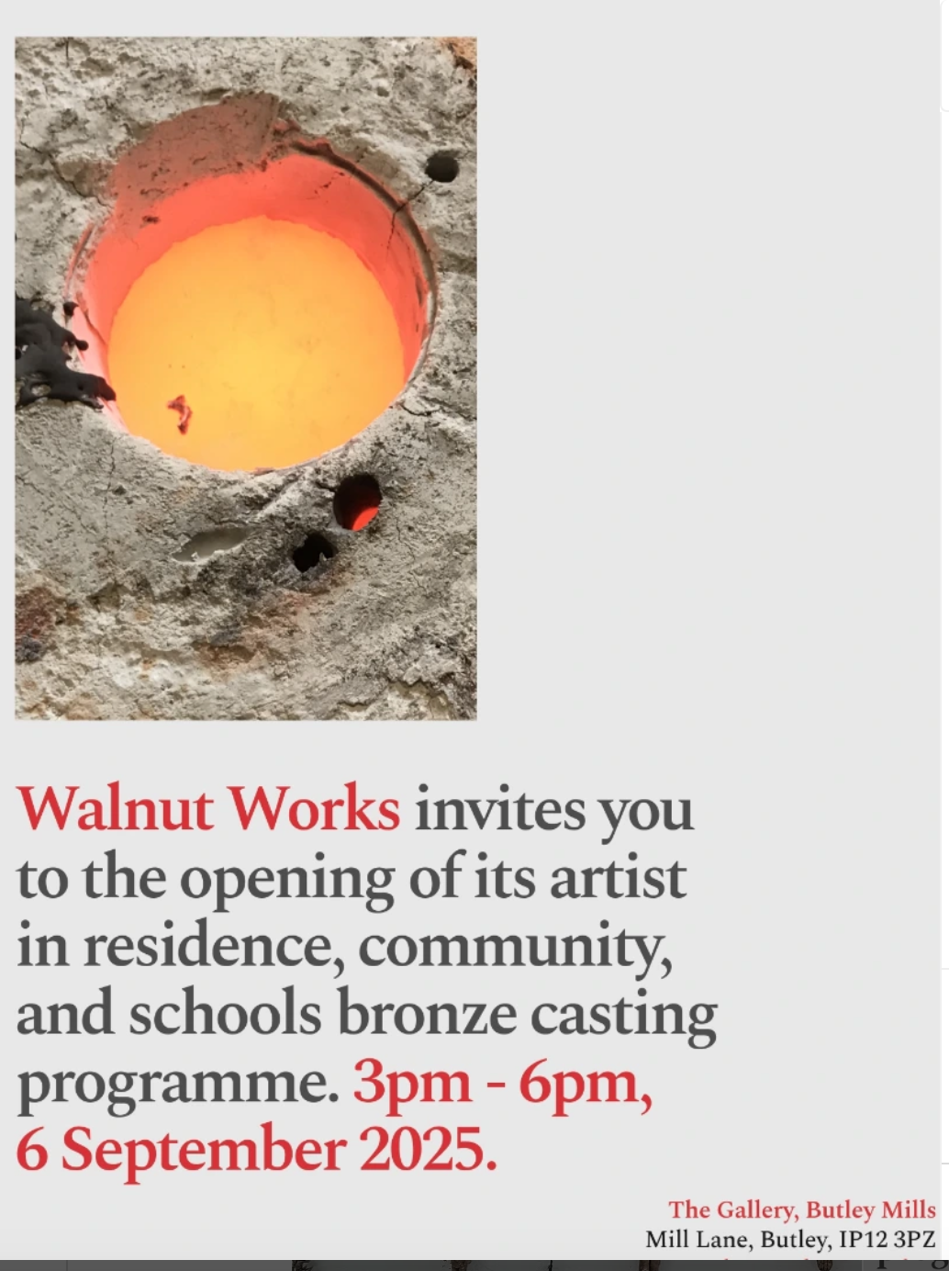
Sees a culmination of work from @walnut_works * community bronze casting project , kicking off with an artist panel talk led by Norwich University of the Arts Senior Lecturer Desmond Brett- 1-2pm in the MAIN STUDIO BUILDING
Then from 3-6pm the exhibition launches in THE GALLERY with work from pupils of Orford Primary School, local care home residents and guest artists in residence ~
@wilsonlaurawilson
@clare_jarrett
@denisedecordova1
@julietlockhartartist
* BMS artists @kabir_hussain_artist & @vckyhussain

