ANY OLD IRON 4TH-11TH OCT 2025

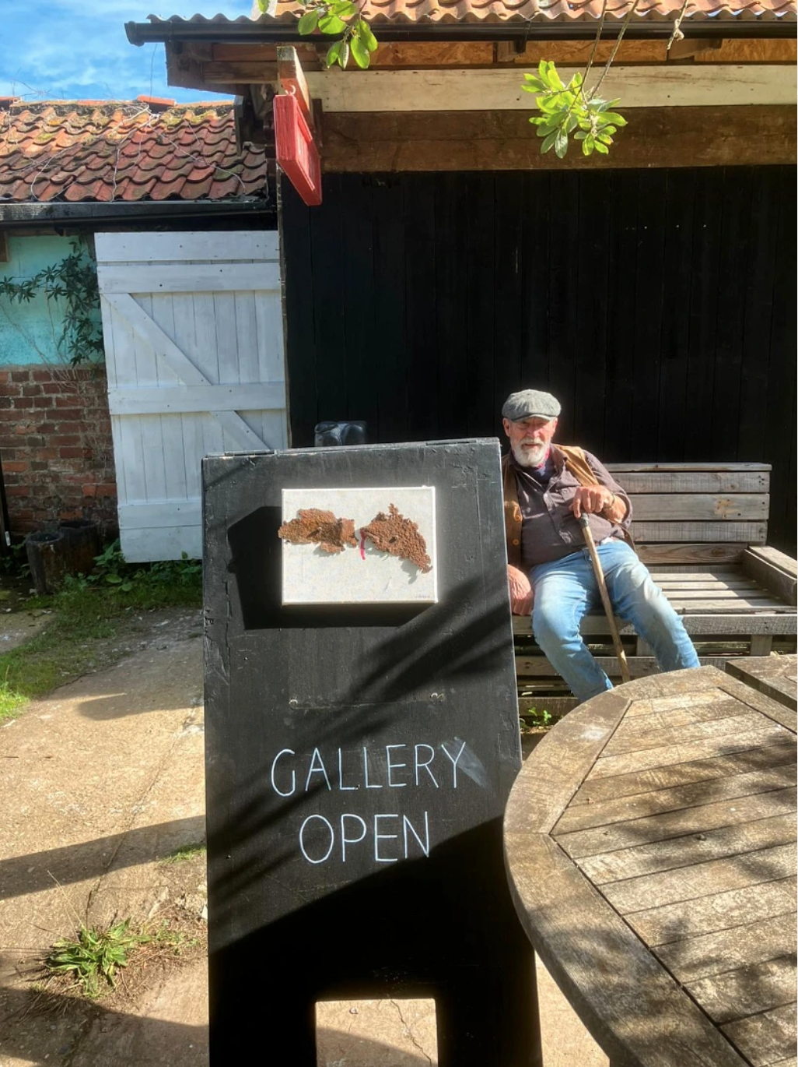
An exhibition by Butley Mills Studio legend John Barker opens in THE GALLERY ✨️TODAY✨️ Oct 2nd 11-4pm.
Also featuring work by fellow BMS artist Ian Sedge @sedgedesignandprint

