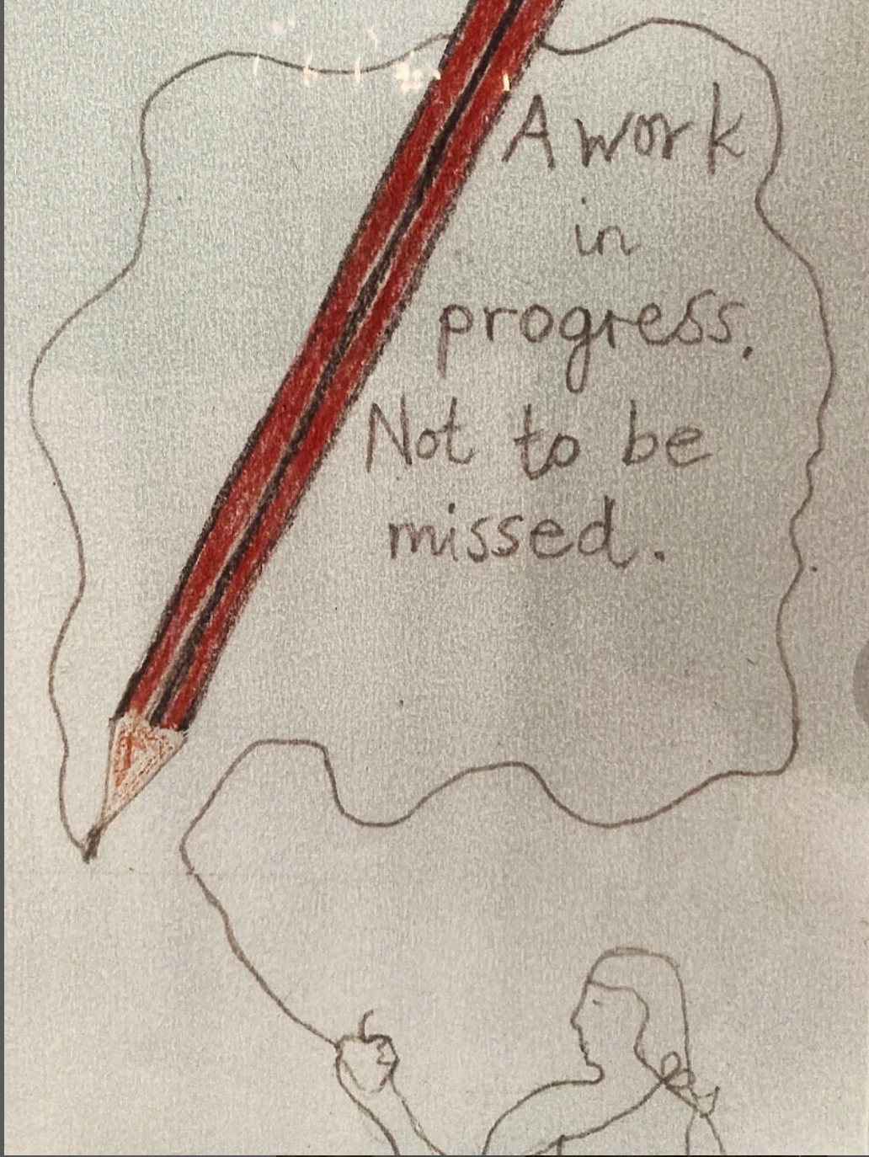
📣 For 2 Days Only! SEPT 20TH & 21ST 📣
HB by Kabir Hussain & Vincent Buckley
@kabir_hussain_artist
@vincent_buckley_22

